ECE 310L: Microelectronic Circuits Lab

Lab 9: BJT Devices

Group 13

Name:

Changyu Guo

Lab partner:

Joe McCarver

# Objectives

1. Use a BJT in the active region to control the average current delivered to a load.
2. Use a BJT operating as a switch to control the average current delivered to a load.

# Background

## Bipolar Junction Transistor

Similar to the MOSFETs studied previously, the bipolar junction transistor (BJT) can be used as a switch or as a linear current-controlled current-source, in a circuit as shown in Figure 1. By operating the transistor in its active region, we can use it as a current-controlled current-source. By controlling the base current, we can directly control the collector current and hence the current delivered to the load. In the active region, *I*C is known by the relationship

*I*C = *β*F*I*B (1)

This relationship will be true as long as the circuit can deliver the required collector current. The term *β*F is the forward current gain of the transistor.

When using the transistor as a switch, we control the average current delivered to the load by using pulse-width modulation (PWM). The switch is only kept on for a fraction of the total time, so the average current is simply the on-state current times the duty cycle. Controlling power in this way generally gives better efficiency, but the switching frequency must be high enough to be imperceptible.

To operate as a switch with low losses, the transistor is supplied with a large enough base current to ensure that the transistor is driven into the saturation region **(which is not the same saturation region as in the MOSFET)**. The transistor enters saturation when both the base-emitter and base-collector junctions are forward biased. The result of both junctions being forward biased is that the collector-emitter voltage becomes fixed at a relatively low voltage (i.e. 0.1 – 0.4 V). In saturation, the active region relationship *I*C = *β*F*I*B breaks down, and the ratio *I*C/*I*B < *β*F is referred to as the forced β.

The BJT is similar to the diode in that minority carriers are the primary charge transport mechanism and must recombine when the transistor is turned off. This results in a significant delay in the off time which is known as the storage time, *t*S.

## Light Emitting Diode

A light-emitting diode (LED) is a basic *pn*-junction diode, except that an LED emits light when the anode lead has a voltage that is more positive than its cathode lead by at least the LED’s forward voltage drop, *V*F. A white LED is typically formed by coating a high-efficiency high-power GaN blue LEDs a Y3Al5O12:Ce, or "YAG", phosphor coating to mix down-converted yellow light with blue to produce light that appears white. One of the key advantages of LED lighting sources is high luminous efficacy. The luminous efficacy is a measurement of the efficiency with which the light source provides visible light from electricity. In 2012, commercially available white LEDs can produce about 200 lumen/W. For comparison, a conventional incandescent light bulb of 60–100 watts emits around 15 lumen/W and compact fluorescent lights emit up to 100 lumen/W.



Figure 1. LED driver circuit

Two popular methods for dimming LEDs exist: analog dimming and pulse-width modulation (PWM) dimming. We will call them linear mode and switched mode power control in this lab. Both methods control the time-averaged current through the LED or LED string. In this lab, we will experiment with both approaches. Through the experiments, you will make observations and examine the advantages and disadvantages of the two types of dimming circuits.

# Materials

* DC power supply, HP E3631A
* Oscilloscope, DSO5014A
* Signal generator, Agilent 33220A
* DMM, Agilent E3631A
* Solderless breadboad
* Hookup wires
* Resistors: As required by your design
* Transistor: 2N2222A
* White LED, Lite-On LTW-2S3D7

# Pre-lab Assignment

Read the lab assignment in its entirety and answer the following questions:

Question 1: Compute the value for *R*C to have a collector current of 25 mA when the transistor is in saturation. Use the transistor datasheet to estimate a value for VCEsat. Do not use the min/max values in the table, use the appropriate plots to estimate. Assume the LED’s *V*F is 3.3V.

Question 2: Compute the value for *R*B such that when *V*IN = 5 V, *I*B will be twice the value required to have a collector current of 25 mA assuming that the transistor is in the active region. Use the transistor datasheet to estimate values for *β* and *V*BE. Do not use the min/max values in the table, use the appropriate plots to estimate. Note that *β* is equivalent to DC Current Gain (*h*FE) in the datasheet.

# Setup

Turn on power to the DMM, oscilloscope, power supply, and signal generator. Set the power supply +6V and +25 current limit to 100mA.

Pay careful attention to the transistor pin-out as shown below to avoid damaging them.



Figure 2. Top down view of BJT transistor 2N2222A.

# Lab Assignment:

1. Use the DMM to measure the values of the resistors. Use the measured component values in your calculations.

Table 1. Measured Resistance

|  |  |  |
| --- | --- | --- |
| Expected Value | 18.9k | 64 |
| Measured Value | 18.7k | 63.37 |

1. Construct the circuit shown in Fig. 1. Set the 25 V output terminals to produce 5 V and connect them to the collector circuit. Set the 6 V output terminals to 0 V and connect as *V*IN.
2. Set *V*IN to 0 V. Measure *V*Rb, *V*Rc, *V*D1, *V*BE, and *V*CE. Use the DMM for the best accuracy. Record the value in Table 2.

Table 2. Measured Voltages at *V*IN = 0

|  |  |  |  |  |  |
| --- | --- | --- | --- | --- | --- |
| Voltages | *V*Rb | *V*Rc | *V*D1 | *V*BE | *V*CE |
| Measurement (V) | 0 | 0 | 2.07V | 1.35mV | 2.93V |

Read the instructions for step 4 – 6 before proceeding.

1. Adjust VIN so that 20 mA of collector current flows, as measured from the voltage across *R*C. If you cannot achieve 20 mA, make circuit modifications as necessary. Record the 6 V output terminal, *V*IN, in the second column of Table 3. Measure *V*Rb, *V*Rc, *V*D1, *V*BE, and *V*CE.

Table 3. Measured Voltages at Various Collector Current

|  |  |  |  |  |  |  |  |  |
| --- | --- | --- | --- | --- | --- | --- | --- | --- |
| Measurements | | *V*IN | *V*Rb | *V*Rc | *V*D1 | *V*BE | *V*CE | *βF* |
| Collector Current *I*C (mA) | 20 | 2.63 | 1.95 | 1.28 | 3.27 | 0.717 | 0.456 | 194 |
| 15 | 2.11 | 1.42 | 0.96 | 3.19 | 0.693 | 0.852 | 199 |
| 10 | 1.64 | 0.975 | 0.64 | 3.09 | 0.644 | 1.26 | 194 |
| 5 | 1.14 | 0.528 | 0.32 | 2.92 | 0.640 | 1.76 | 179 |

1. Repeat step 4 for collector currents of 15 mA, 10 mA, and 5 mA. Record the measurements in Table 3.
2. Calculate the the amount of power dissipated by the BJT at the collector current of 20 mA.
$$P=VI=V_{CE}*Ic=0.456*0.02=0.00912$$

3. While adjusting the collector currents in Step 4 – 5, hold a piece of white paper on top of the LED. How does the brightness changes as the collector current changes, *I*C, from 20 mA to 5 mA?

The brightness decrease as I­c decrease from 20mA to 5mA

Or the light getting dimmer

1. Calculate *β*F for each operating point in the active region. Record the values in Table 3. How does the measured *β*F compare to the datasheet value?

*β*F= Ic/Ib

*β*F measured and calculated is smaller than *β*F from data sheet

Read the instructions for step 8 – 13 before proceeding.

1. Disconnect the 6 V power supply from VIN and connect the signal generator in its place. Adjust the signal generator for a 0 – 5 V pulse at 250 Hz. Set the duty cycle to 20% and the output impedance to High-Z.
2. Set the signal generator duty cycle, *D*, so that the average collector current is 20 mA. Measure the average current with oscilloscope. 1.26v
3. Plot the waveform traces for *V*D1, *V*Rcand *V*CE in three rows using MATLAB subplot command. Please be careful how you connect the probes as both oscilloscope channels share the same ground. Improper connection could short out the circuit. Not all waveform traces can be directly captured from the oscilloscope.

5-VD1 = measured

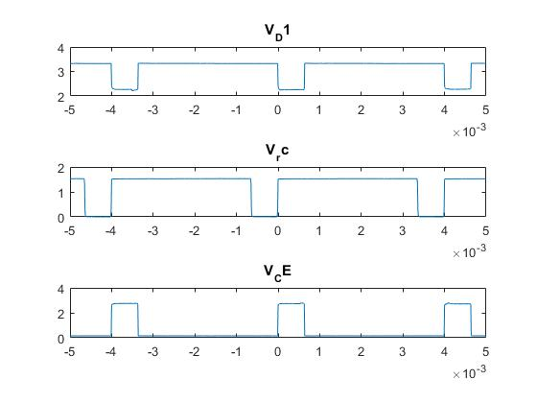

1. Measure the minimal and maximal values of *V*Rc, *V*D1, and *V*CE at different average collector current. These are *not* the average values. Record the measurements in the second row of Table 4.

Table 4. Measured Voltages under Pulsed Mode while the Transistor is ON

|  |  |  |  |  |  |  |  |  |
| --- | --- | --- | --- | --- | --- | --- | --- | --- |
| Measurements | | *D* | *V*Rc | | *V*D1 | | *V*CE | |
| Min | Max | Min | Max | Min | Max |
| Average Collector Current *I*C (mA) | 20 | 84% | 0 | 1.53 | 2.21 | 3.35 | 0.150 | 2.77 |
| 15 | 63% | 0 | 1.5 | 2.2 | 3.37 | 0.140 | 2.80 |
| 10 | 43% | 0 | 1.48 | 2.2 | 3.41 | 0.140 | 2.81 |
| 5 | 22% | 0 | 1.45 | 2.2 | 3.43 | 0.140 | 2.76 |

1. In the space below, show the amount of power dissipated by the BJT at the average collector current of 20 mA. Please note that the signal is time-varying, the power needs to be integrated over a full period. Also pay attention to the timing of *I*C and *V*CE waveform when performing the integration. Ignore the overshoot and undershoot of in the waveform.

No need to integrate

$$P=VI*D=V_{CE}*Ic*D=1.53*0.02*0.84=0.0257 W$$

1. How does the power dissipation in BJT in the switching mode compare with the linear mode for the collector current of 20 mA?

Power dissipation in PWM mode is higher than linear mode

1. Repeat step 8-11 for average collector currents of 15 mA, 10 mA, and 5 mA. Record the measurements in Table 4.

For some BJTs and LEDs, it might be difficult to obtain an averaged collector current of 5 mA by changing the duty cycle of a rectangular waveform. In such case, use pulse mode on the signal generator.

1. While adjusting the average collector currents in Step 9 – 12, hold a piece of white paper on top of the LED. How does the brightness changes as the collector current changes, *I*C, from 20 mA to 5 mA?

The brightness decrease as I­c decrease from 20mA to 5mA

Or the light visibly dims

1. Calculate the power dissipated by the transistor for each point in both the linear and switched modes. (Ignore the power consumed by the base circuit.) Plot both sets of power dissipation data versus average collector current. Describe and explain your observations.

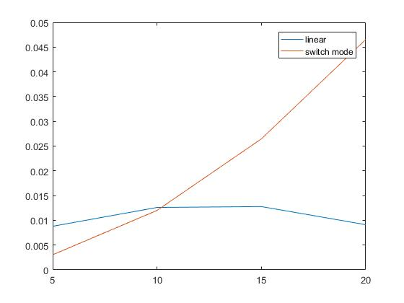

1. Calculate the efficiency of the collector circuit in delivering power to the combination of *R*C and the LED in both the linear and switched modes. (Ignore the power consumed by the base circuit.) Plot both sets of efficiency data versus average collector current on a single graph. Describe and explain your observations.
2. The results shown in step 6, 11–13 point out some pros and cons of linear and switch-mode power control. Summarize the advantages and disadvantages.
3. Based on the *V*BE and *V*CE(sat) data that you observed, is it reasonable to approximate these values by a fixed voltage drop?

1. Set the signal generator duty cycle to the value that causes 10 mA of average collector current. Measure the delay between input voltage and output voltage. Take screen captures for both rising and falling edges of *V*CE with *V*IN using an appropriate timebase. Comment on what you observed.

Delay is 585ns